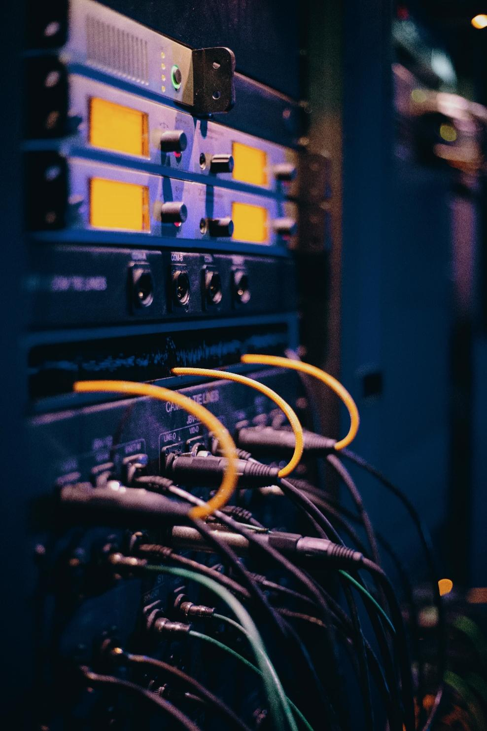

Network Design Report

WESTOR COMPANY NETWORK DESIGN Report

Tayaba Mahmood | Computer Networks Lab | 230201122

### ****Project Overview:****

This project demonstrates a complete organizational network setup using Cisco Packet Tracer. The network is divided into multiple departments (Reception, HR, Finance, and Marketing), each with its own set of devices such as PCs, printers, smartphones, and laptops. The network includes both wired and wireless connectivity, with critical services like DNS and email servers implemented to support efficient communication and resource sharing. Routers and switches are used to interconnect these departments, ensuring seamless communication within and between them.

### ****IP Addressing Scheme:****

Each department is configured with its own subnet to ensure proper organization and manageability.

**Reception Department**:

* 1. **Subnet**: 192.168.4.0/24
  2. **Devices**:
     1. PC-Fa0: 192.168.4.11
     2. Laptop-Reception: 192.168.4.12
     3. Smartphone-Reception: 192.168.4.14
     4. Printer: 192.168.4.13
  3. **Access Point**: ReoAP (192.168.4.15)

**HR Department**:

* 1. **Subnet**: 192.168.2.0/24
  2. **Devices**:
     1. PC-HR1: 192.168.2.11
     2. PC-HR2: 192.168.2.12
     3. HR Printer: 192.168.2.10
     4. HR Tablet: 192.168.2.14
     5. HR Smartphone: 192.168.2.15
  3. **Access Point**: HR-AP (192.168.2.16)

**Finance Department**:

* 1. **Subnet**: 192.168.1.0/24
  2. **Devices**:
     1. PC-Fin1: 192.168.1.11
     2. PC-Fin2: 192.168.1.12
     3. Fin Printer: 192.168.1.13
     4. Laptop-Fin: 192.168.1.14
     5. Smartphone-Fin: 192.168.1.15
  3. **Access Point**: FinAP (192.168.1.16)

**Marketing Department**:

* 1. **Subnet**: 192.168.3.0/24
  2. **Devices**:
     1. PC-Muser1: 192.168.3.10
     2. PC-Muser2: 192.168.3.11
     3. Marketing Printer: 192.168.3.12
     4. Marketing Laptop: 192.168.3.16
     5. Marketing Smartphone: 192.168.3.14
  3. **Access Point**: MK-AP (192.168.3.17)

**DNS and Email Server**:

* 1. **DNS Server**: 192.168.1.5
  2. **Email Server**: 192.168.1.6

### ****Network Connectivity:****

**Switches**:

* 1. Each department has its own switch to connect all wired devices such as PCs and printers.
  2. VLANs can be implemented to logically segment traffic within departments.

**Routers**:

* 1. Three routers (Router1, Router2, and Router3) interconnect all the departmental subnets.
  2. They facilitate inter-department communication and manage routing between subnets.
  3. Static or dynamic routing protocols (e.g., RIP, OSPF) are configured for effective data transfer.

**Access Points**:

* 1. Used in each department to provide wireless connectivity to devices like smartphones, tablets, and laptops.
  2. Example: Reception’s smartphone connects to the ReoAP to access the network.

**Server Connectivity**:

* 1. All departments access the DNS and email servers through the routers.
  2. The DNS server resolves domain names to IP addresses, while the email server handles organizational email communication.

### ****Functionalities of Network Components:****

#### ****1. Routers****

* Connect multiple departments by routing data packets between different subnets.
* Example: HR PCs can communicate with Finance PCs through the routers.

#### ****2. Switches****

* Provide connectivity within departments by connecting PCs, printers, and access points.
* Ensure efficient local communication through Layer 2 data forwarding.

#### ****3. Access Points****

* Extend network access to wireless devices within the department.
* Provide mobility and flexibility for devices like laptops and smartphones.

#### ****4. DNS Server****

* Resolves domain names to IP addresses to facilitate resource access.
* Example: A Marketing PC uses DNS to resolve the email server’s hostname.

#### ****5. Email Server****

* Allows employees to send and receive emails both internally and externally.
* Example: HR staff can use the email server to communicate with the Marketing department.

#### ****6. End Devices****

* PCs, laptops, smartphones, and printers are used for daily organizational tasks.
* Printers are shared resources accessible by multiple devices.

Finance Department:

The Finance Department's network is designed to support secure and efficient financial operations. It includes:

* **3 PCs and 1 Laptop**: Used for daily financial tasks, accounting, and budget management.
* **1 Smartphone and 1 Tablet**: Provide mobility for finance staff to access essential resources on the go.
* **1 Printer**: Dedicated for printing invoices, reports, and financial documents.

All devices are connected through a departmental VLAN to ensure secure data transmission, while shared resources like the printer are easily accessible to all authorized devices. This setup guarantees smooth financial workflows and data security.

IP configurations:

192.168.1.10 - 192.168.1.15

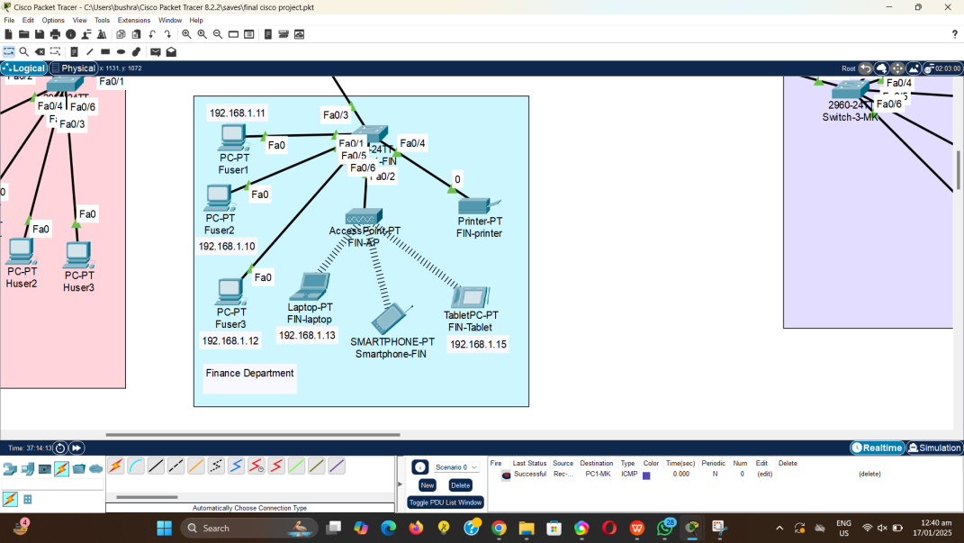

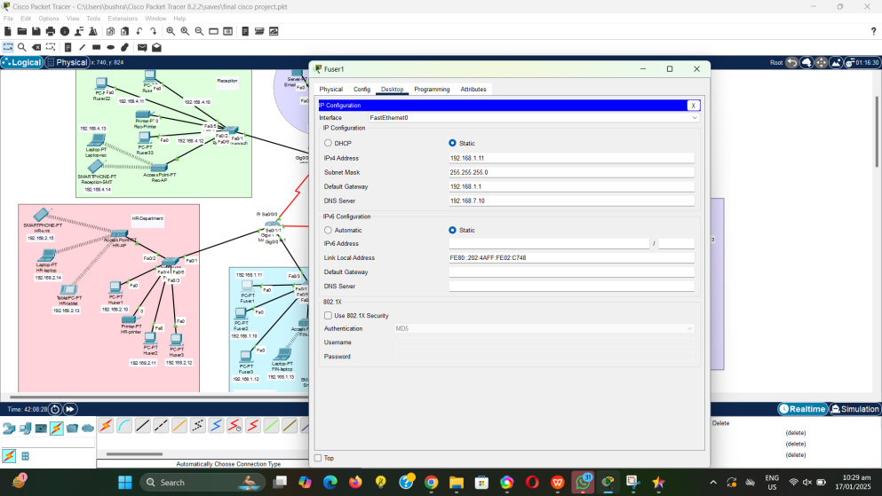

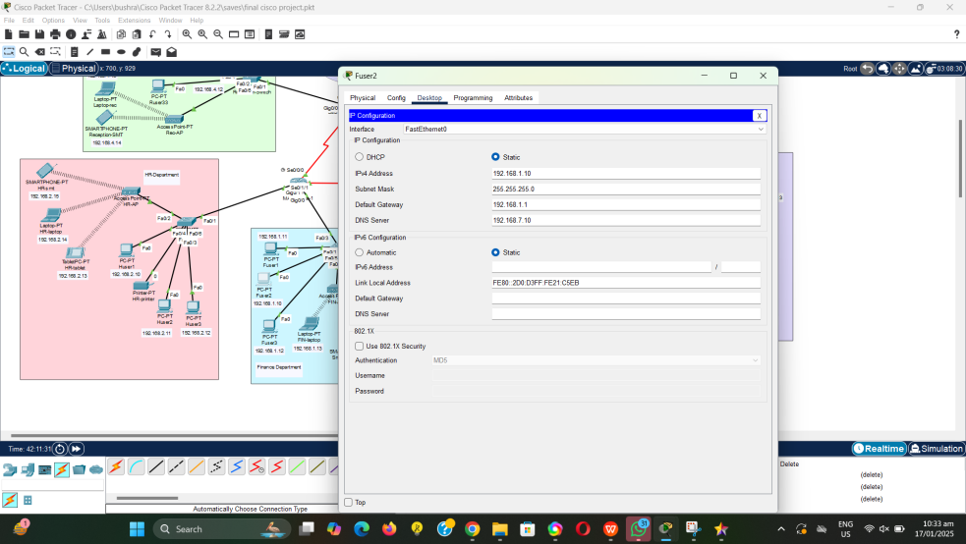

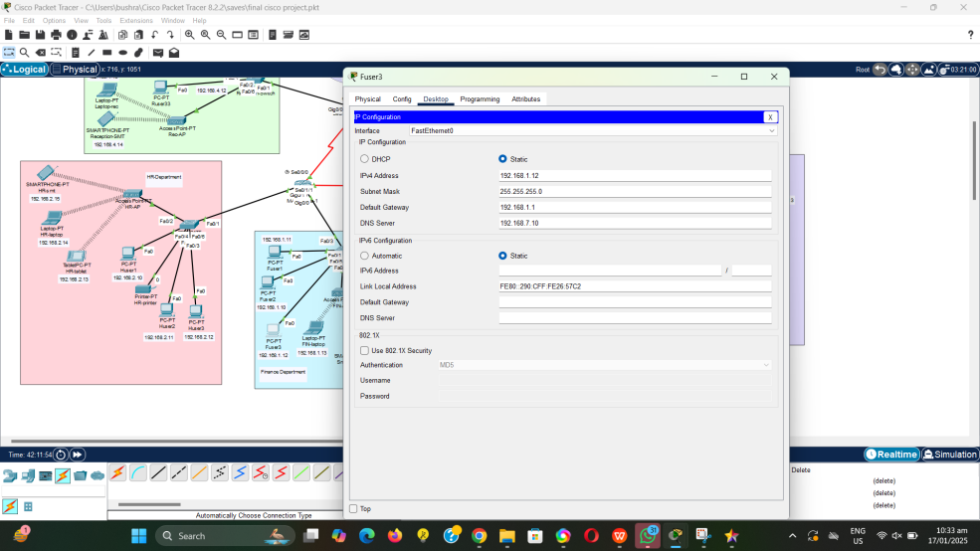

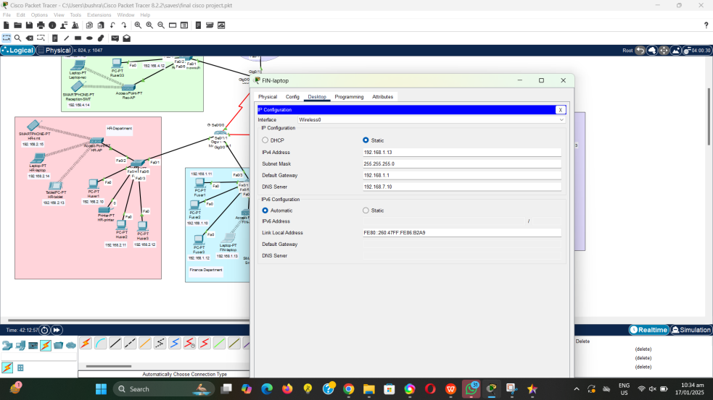

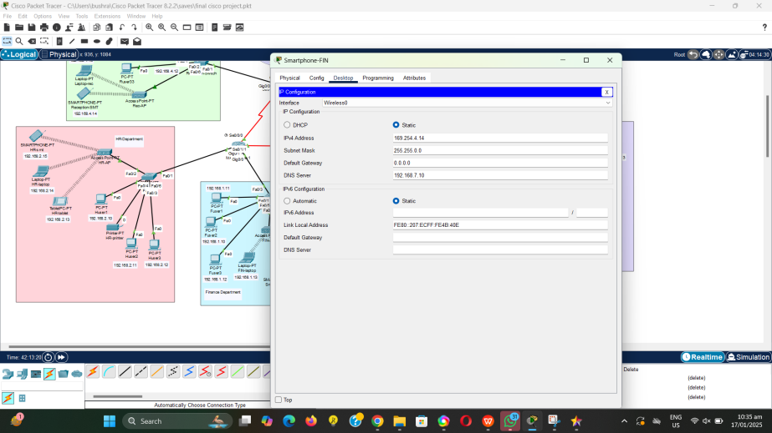

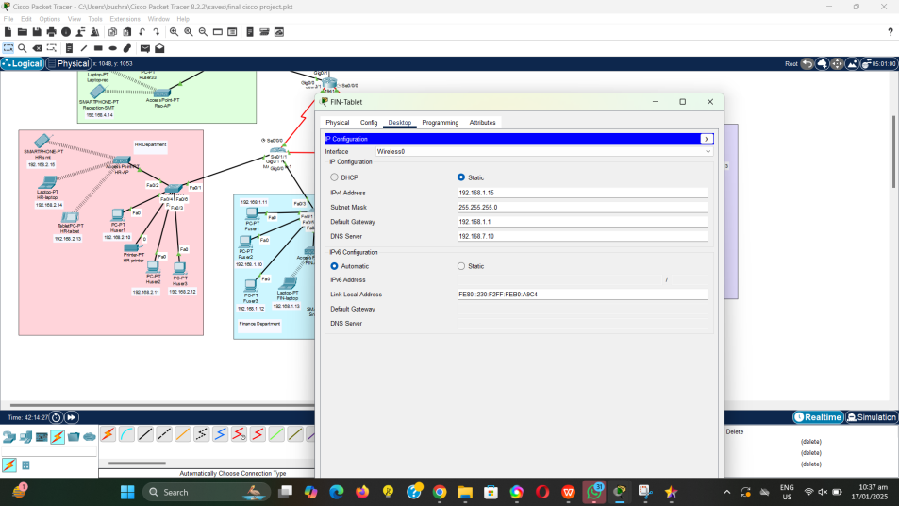

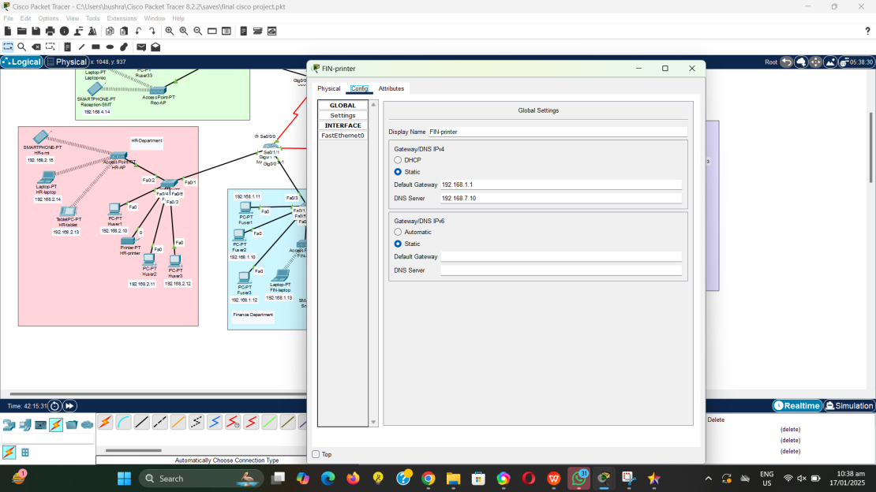

HR Department:

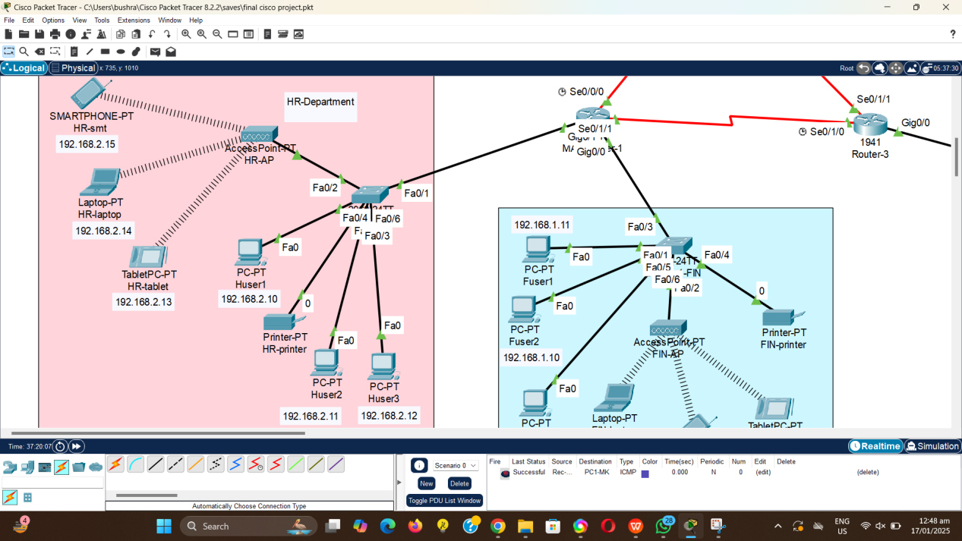

### HR Department Network Description

The HR Department's network is designed to facilitate seamless communication and efficient management of human resources. It includes:

* **3 PCs and 1 Laptop**: Used for managing employee records, recruitment processes, and payroll systems.
* **1 Smartphone and 1 Tablet**: Enable mobility for HR staff to stay connected and perform tasks remotely.
* **1 Printer**: Dedicated for printing employee documents, contracts, and HR reports.
* **1 Access Point**: Provides wireless connectivity for mobile devices, ensuring flexibility and ease of access.

This setup ensures reliable connectivity and secure data management for effective HR operations.

Access Points Password:

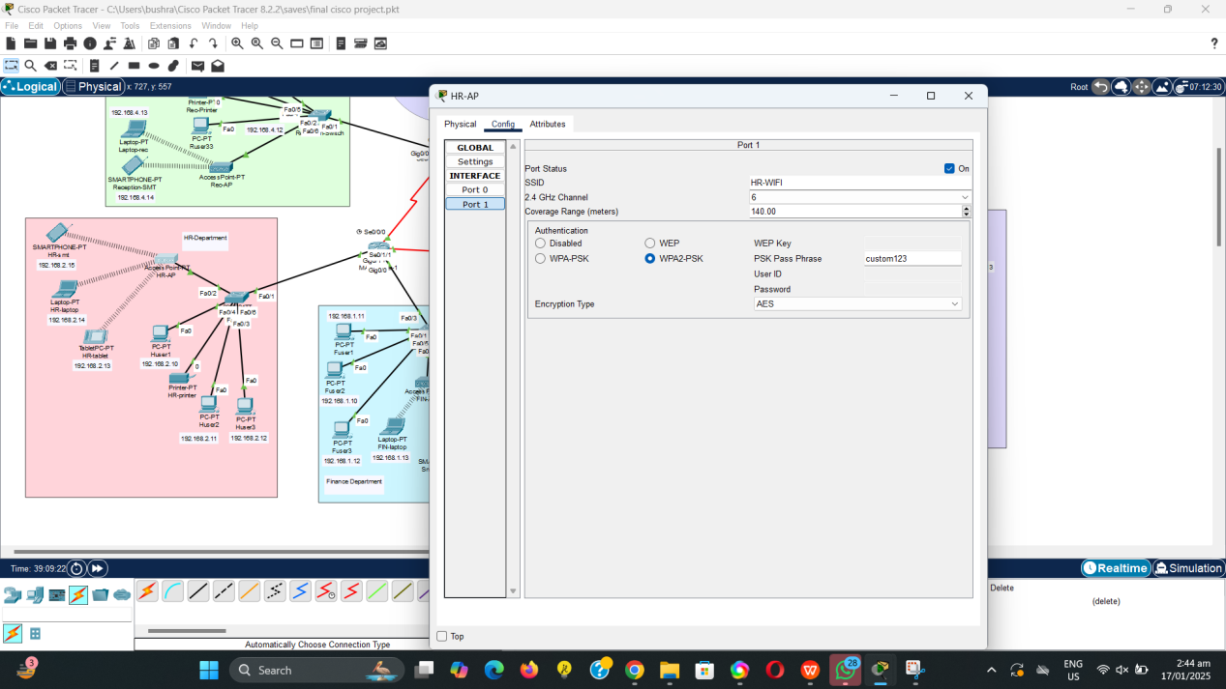

Connectivity with access points:

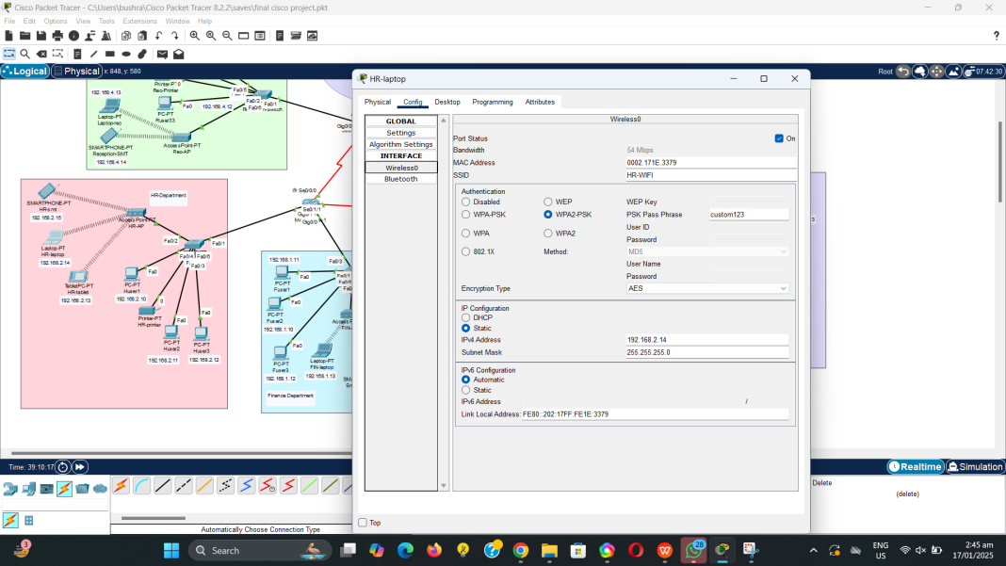

IP configurations:

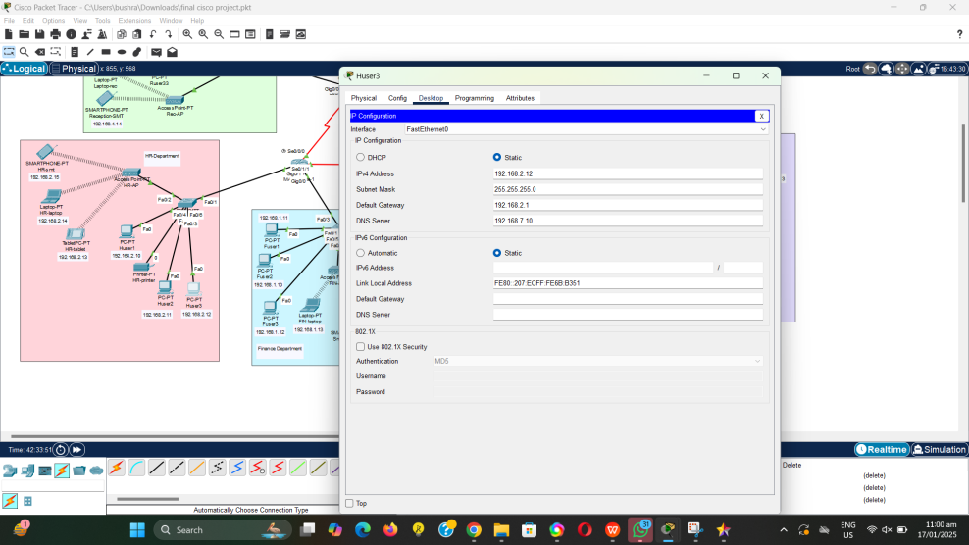

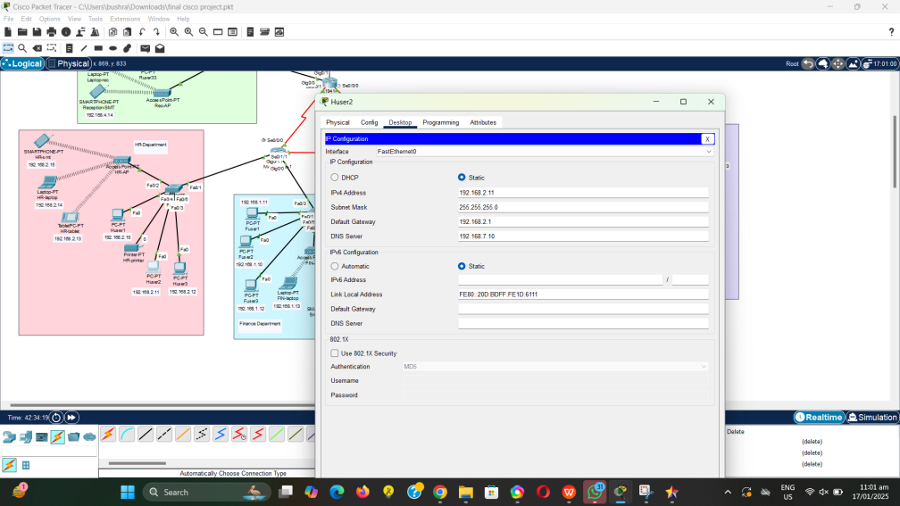

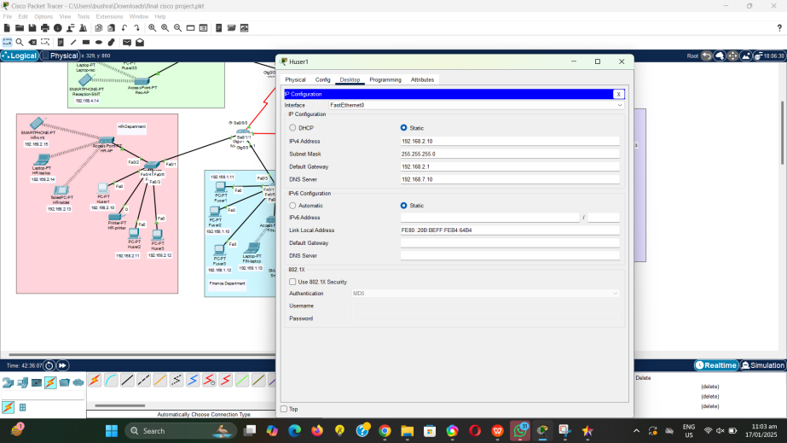

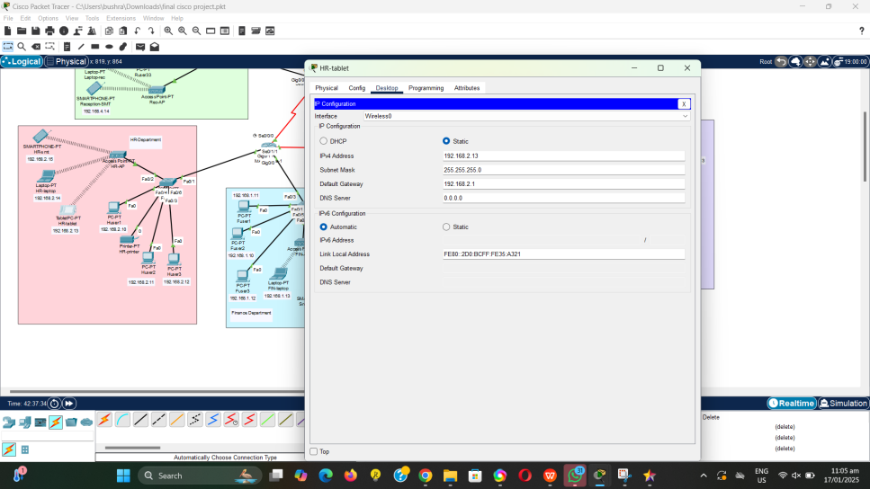

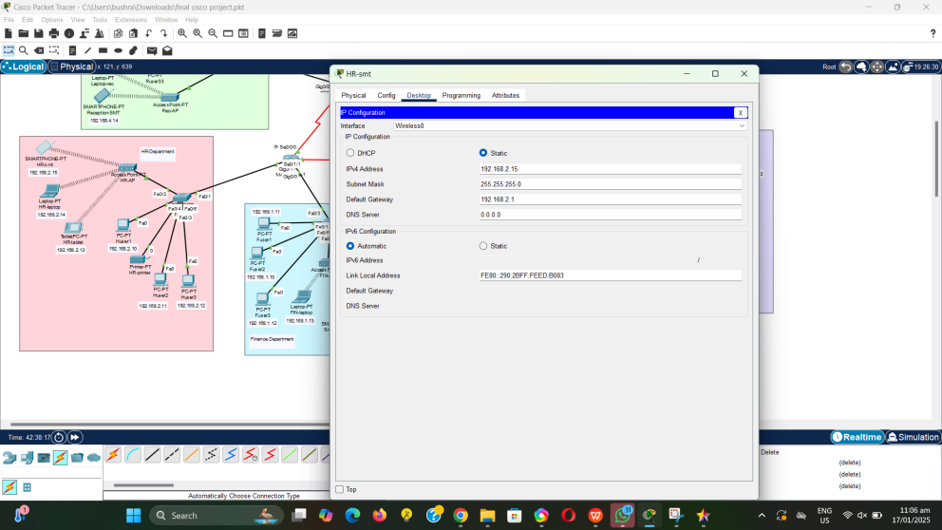

Access Points:

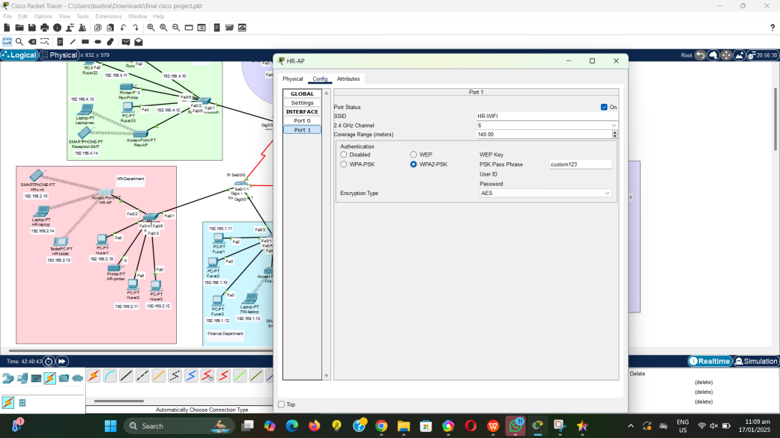

Marketing Department: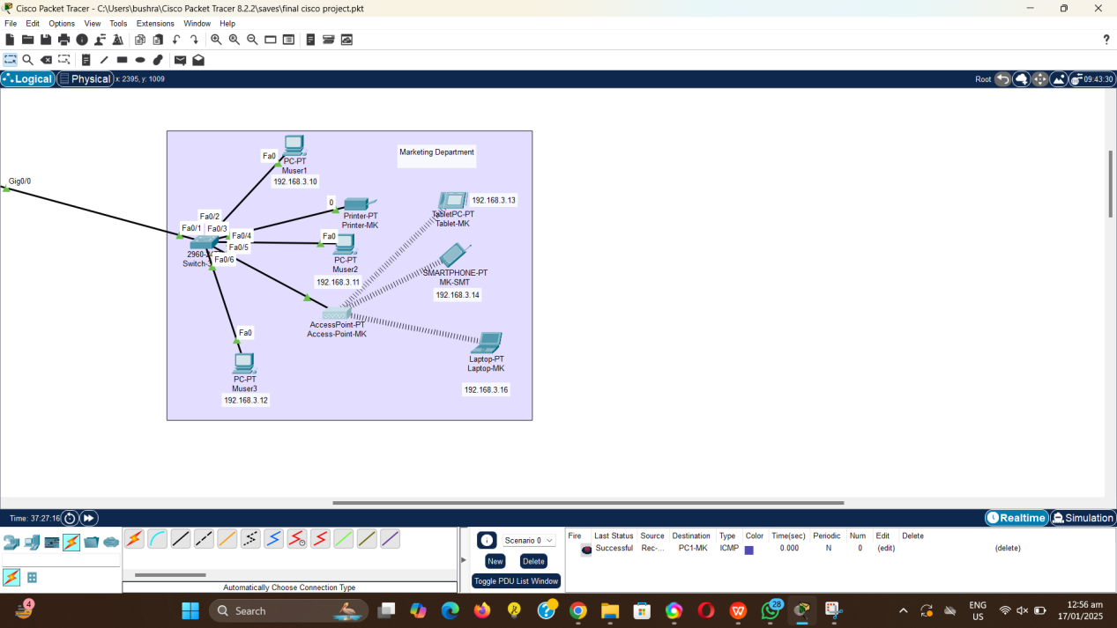

IP’s:

192.168.3.10 - 192.168.3.16

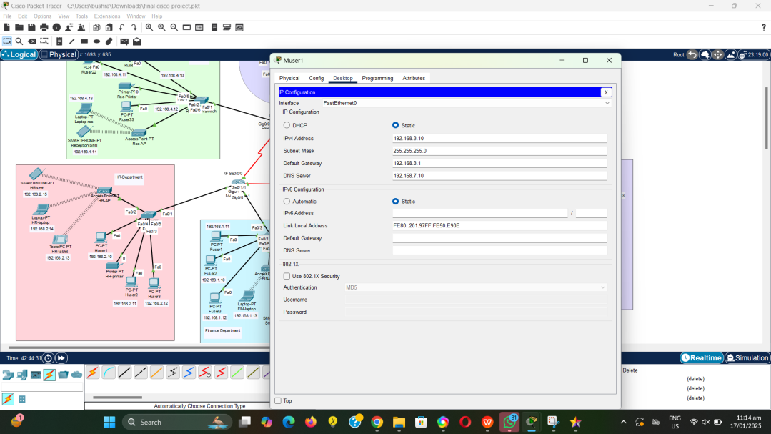

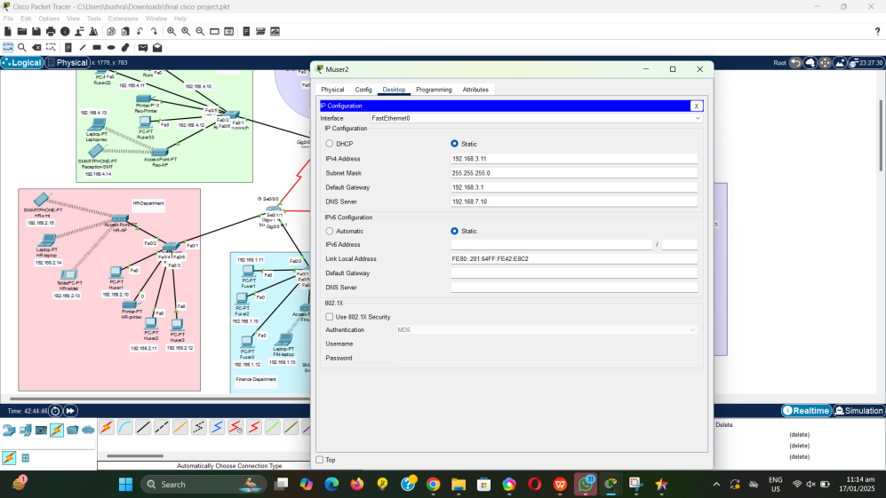

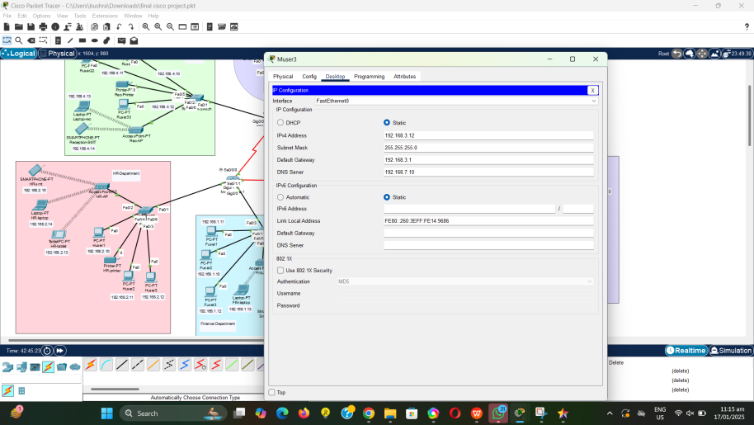

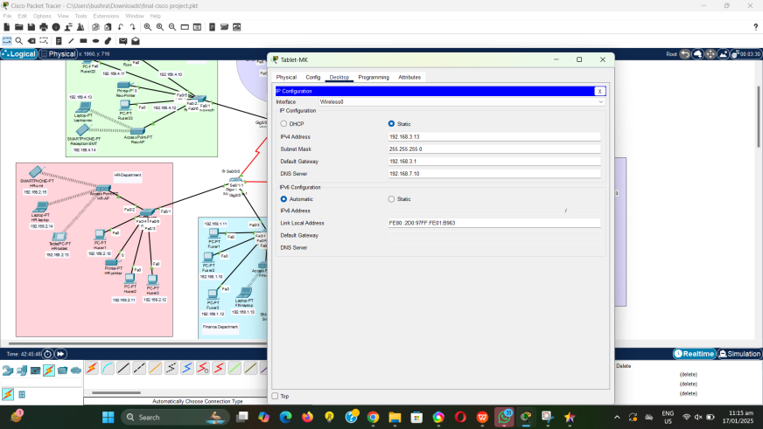

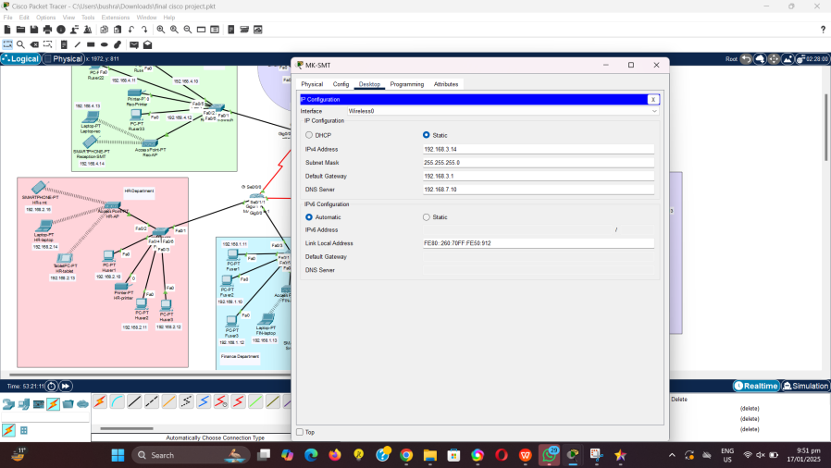

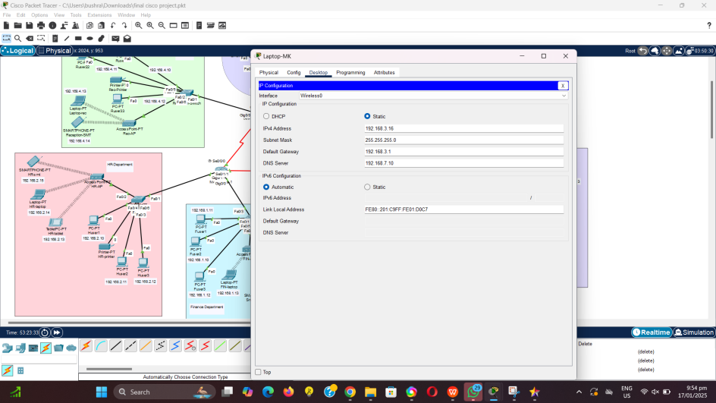

Reception:

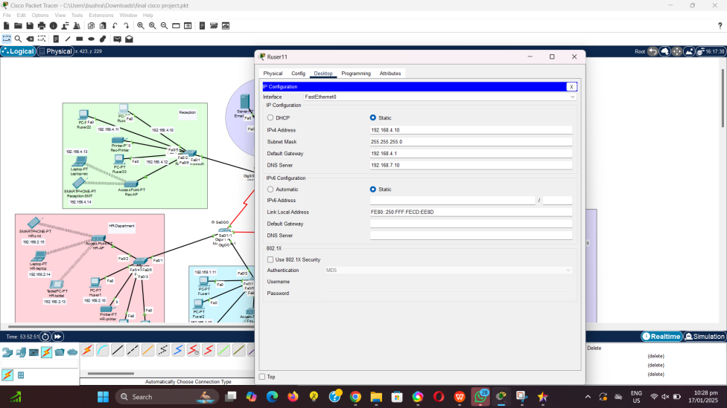

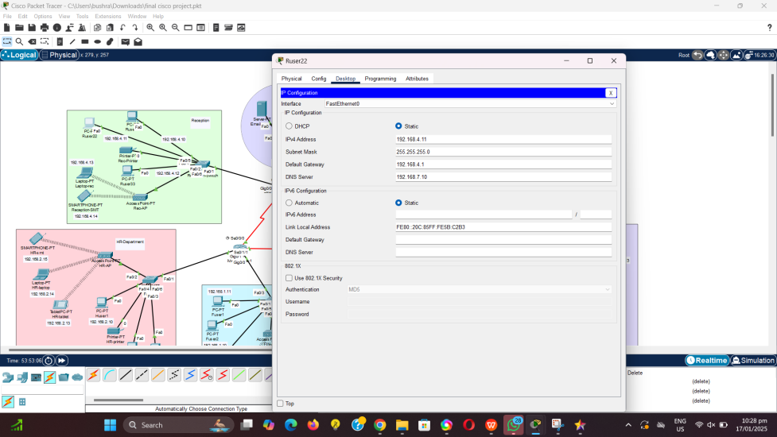

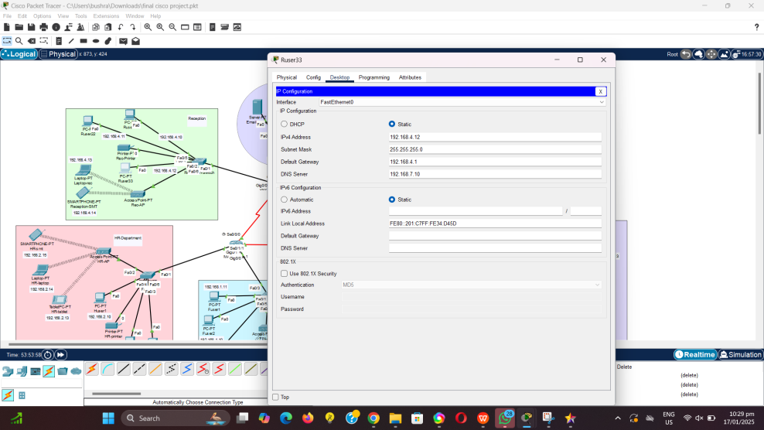

Access points:

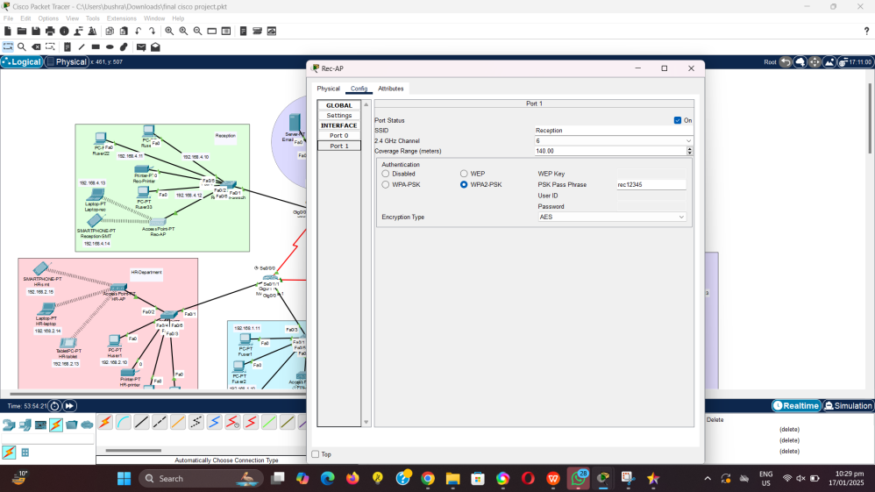

Email Server:

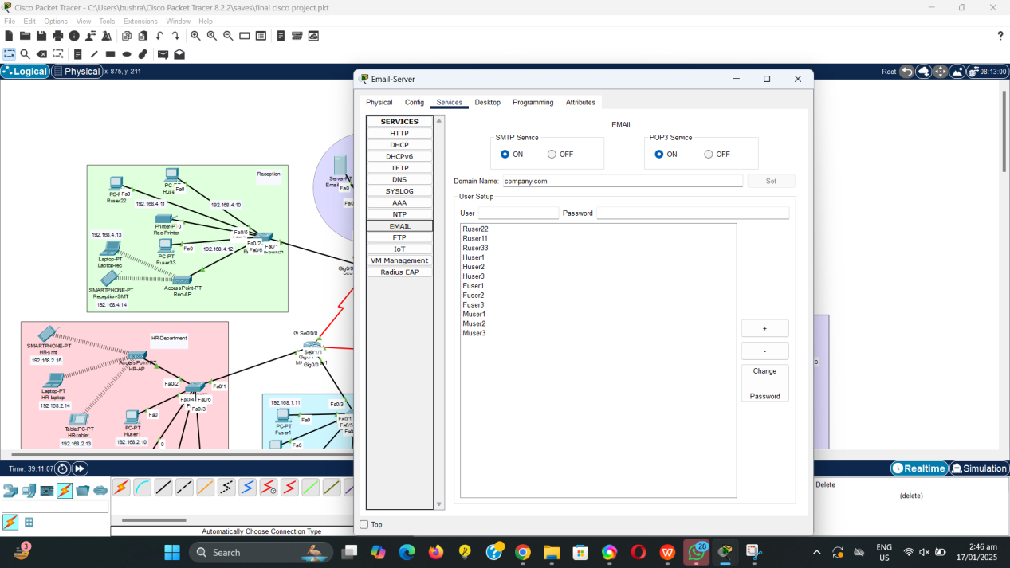

Sending and recieveing emails:

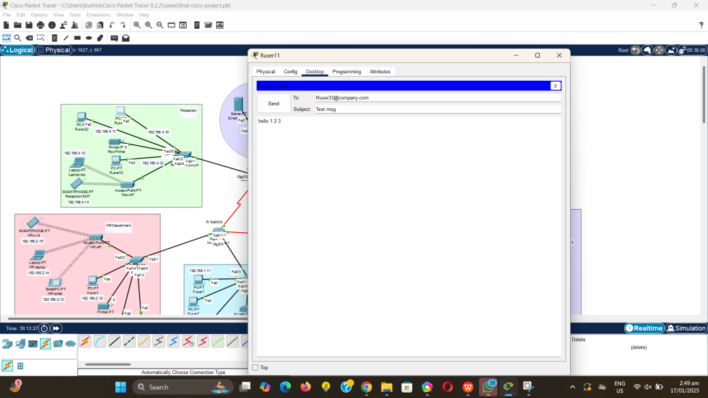

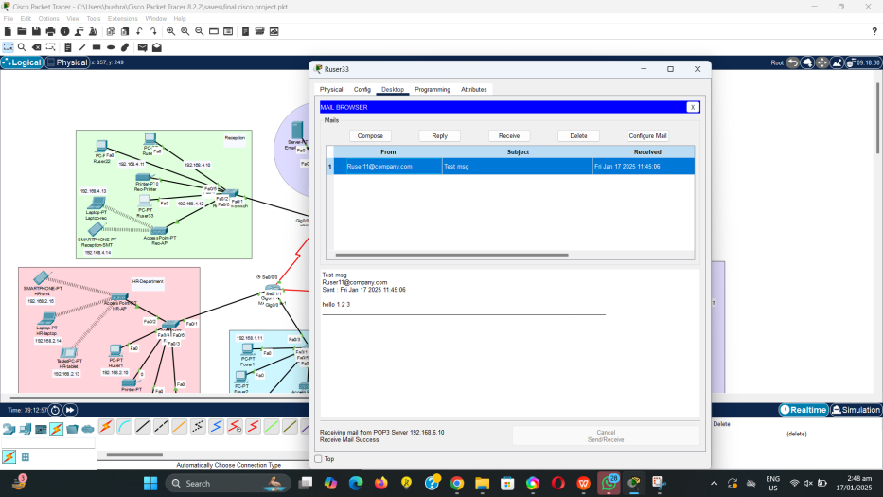

Router-1:

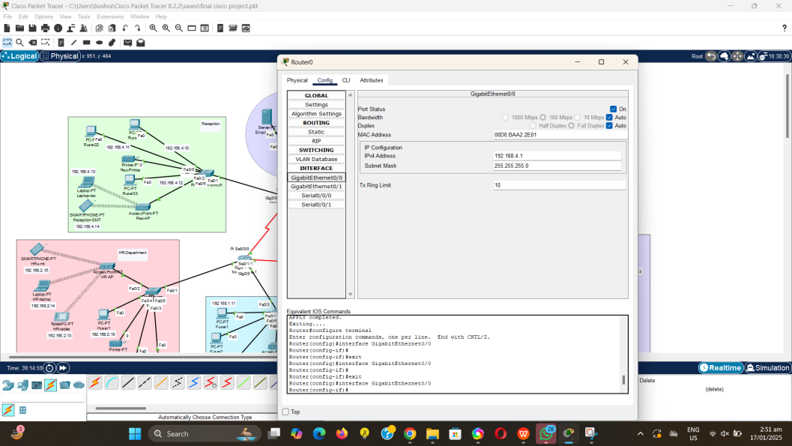

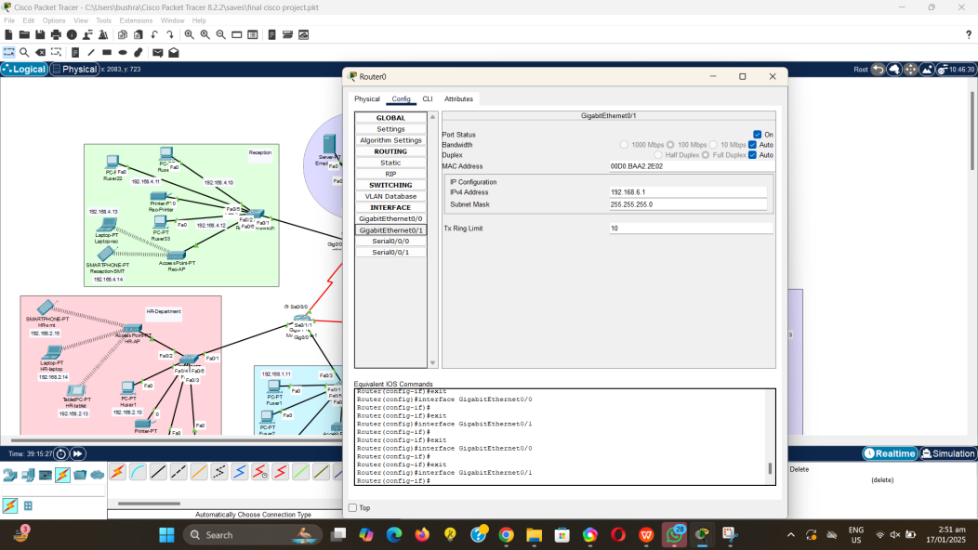

Router 1 Serial Ports:

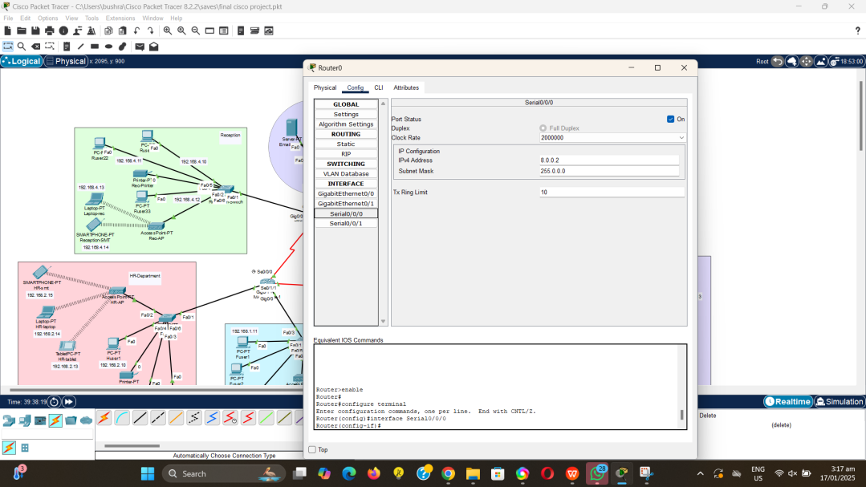

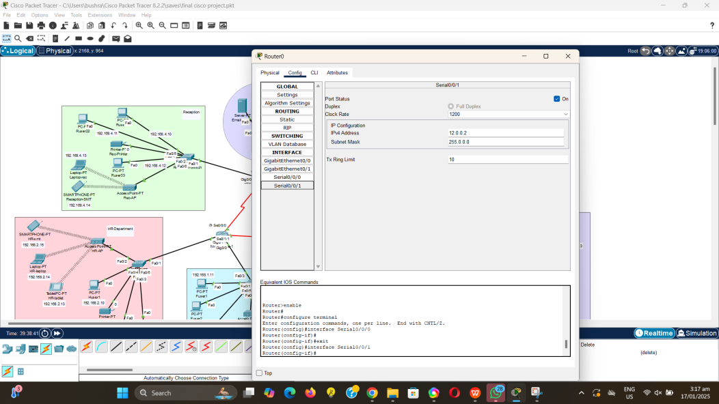

Main-router 1 RIP:

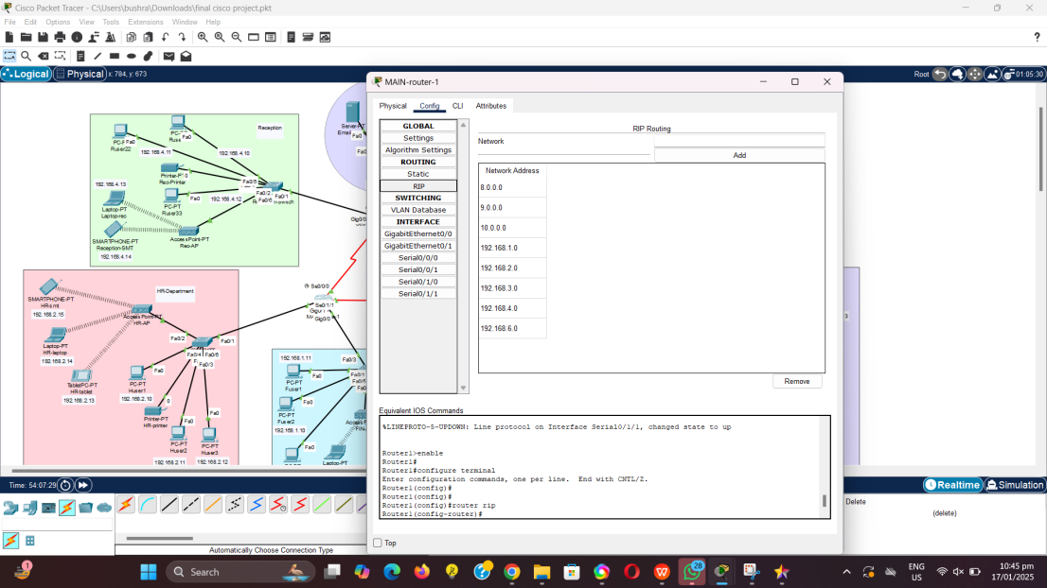

Checking connectivity by sending packets:

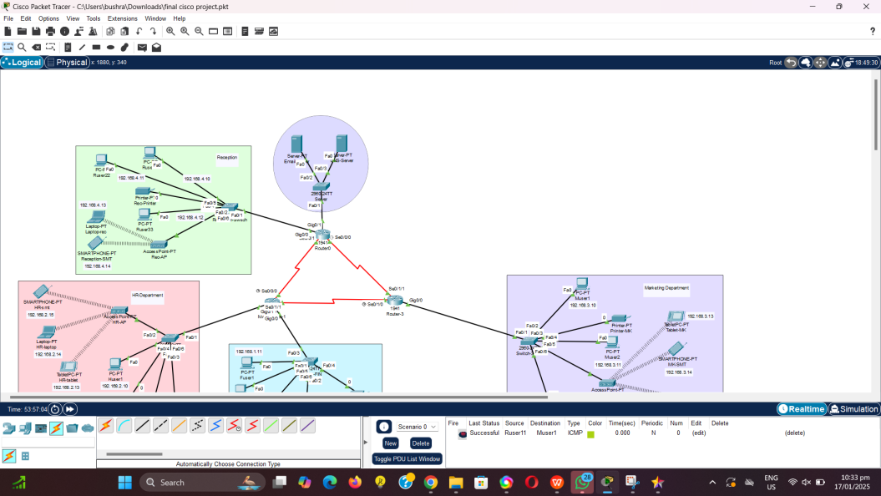

Checking connectivity by pinging:

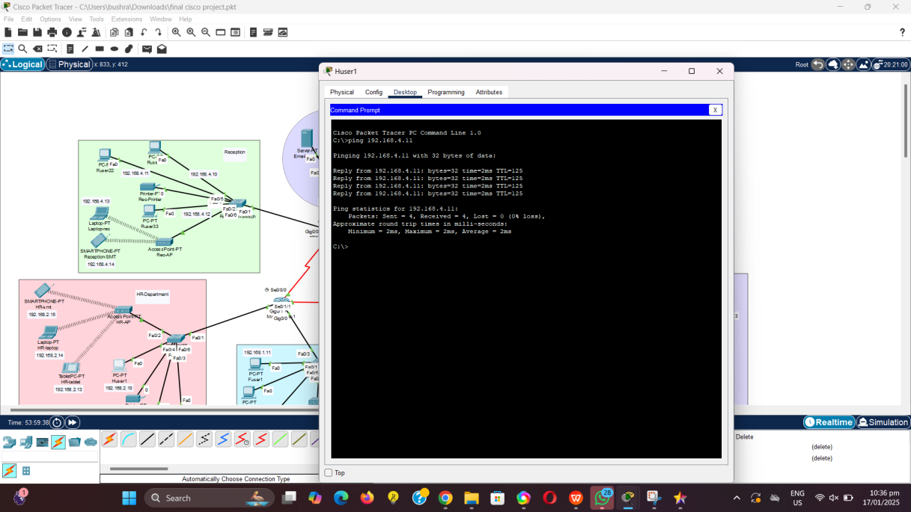

Webpage of the company:

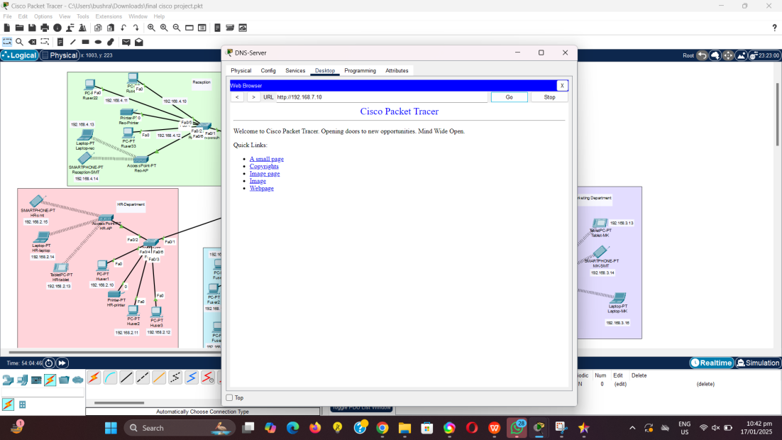

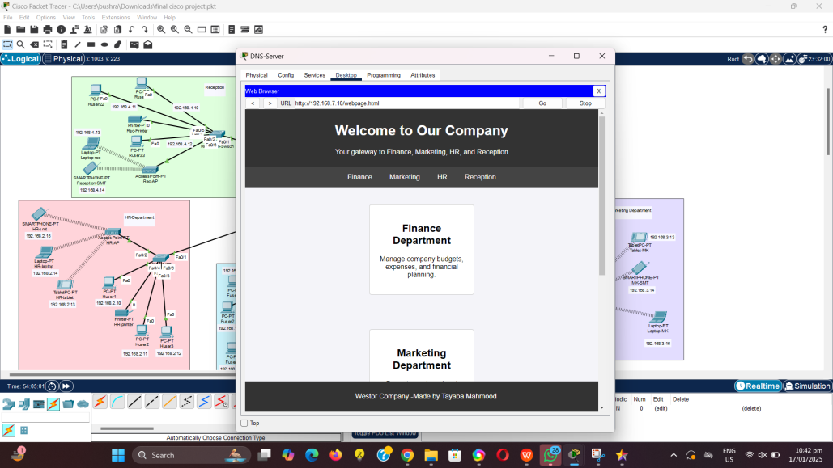

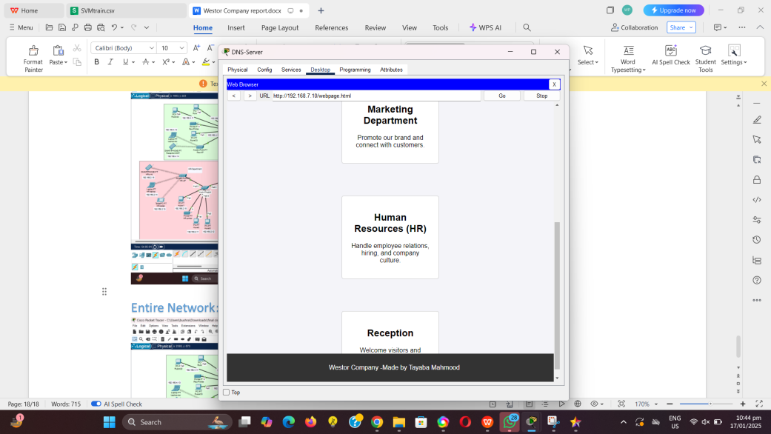

Entire Network:

